Task 1:
Big Data in Daily Life – Visual Storytelling: Healthcare Analytics

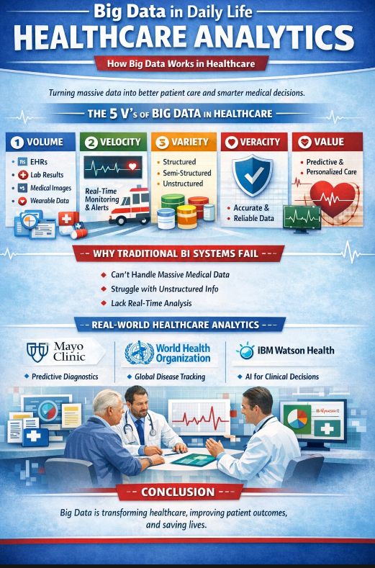
Imagine visiting a hospital where your medical history, lab reports, prescriptions, and even smartwatch data are instantly available to your doctor. This seamless experience is powered by Big Data in Healthcare Analytics.
Healthcare data is classified into three types. Structured data includes organized records like patient details, billing information, and lab results. Semi-structured data includes wearable sensor logs and e-prescriptions. Unstructured data consists of doctor’s notes, medical images (MRIs, CT scans), and audio records.
This system works through the 5 Vs of Big Data: Volume (massive medical records), Velocity (real-time monitoring), Variety (different data formats), Veracity (accuracy and reliability), and Value (better diagnosis and treatment).
Traditional BI systems fail because they cannot process large imaging files, unstructured notes, or real-time data efficiently. Big Data is required to analyze complex health patterns, predict risks early, personalize treatments, and transform healthcare from reactive care to proactive, life-saving decision-making.

